|  |  |  |  |  |  |  |  |  |
| --- | --- | --- | --- | --- | --- | --- | --- | --- |
| |  | | --- | | Sirui SR3204 Carbon tripod | | Product image thumb |  |  |  |  |  | | --- | --- | --- | --- | | Product image thumb | Product image thumb | Product image thumb |  | |  | **Featured information** The Sirui SR3204 Carbon tripod with a load capacity of up to 25kg is especially suitable for working in studios or using a combination of DSLR cameras, large video cameras. The tripod design is only 54.36cm when folded, but the maximum height can reach 150cm to support users to create the best art products.  **Price: 300$**  **Specifications:**   * **Weight:** 5kg * **Max height:** 150cm * **Minimum height:** 11.9cm * **Load bearing:** 25 Kg |

**Description:**

#### **Sirui SR3204 Carbon tripod**

Sirui SR3204 Carbon is made of carbon fibers, supporting a tripod with a load of up to 25kg. With a large bearing capacity, this tripod is suitable for use with DSLR cameras and large video cameras. Sirui SR3204 has a compact design (only 54.36cm when folded), weighing 2kg makes it easy for photographers to carry on business trips.

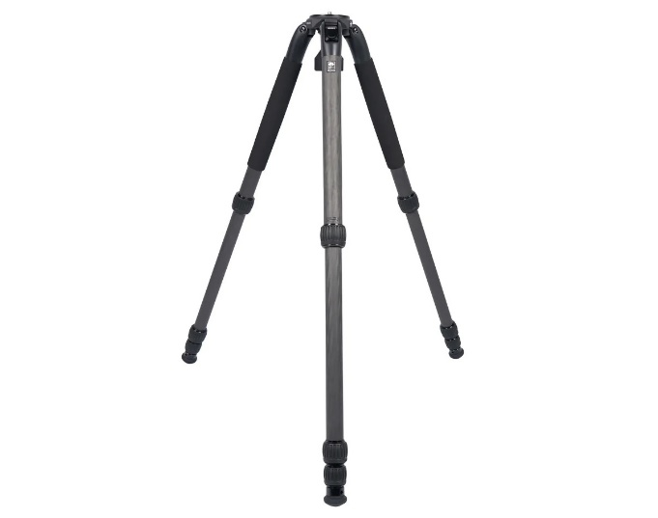

Sirui SR3204 uses S-grade design with convenient curved legs for easy and comfortable operation. At the same time, this design also allows the tripod to better distribute force on each leg, ensuring stability when used.